**✅ Task 3: REST - Get Country Based on Country Code**

**Scenario:**

This task involves creating a RESTful web service using Spring Boot that returns a specific country’s details when the country code is passed in the URL. The country data is fetched from the XML configuration file (country.xml). The matching is done case-insensitively using the @PathVariable annotation. This eliminates the need for a separate service layer.

**Controller Code (CountryController.java):**

package com.cognizant.spring_learn.controller;

import com.cognizant.spring_learn.Country;

import org.slf4j.Logger;

import org.slf4j.LoggerFactory;

import org.springframework.context.ApplicationContext;

import org.springframework.context.support.ClassPathXmlApplicationContext;

import org.springframework.web.bind.annotation.*;

import java.util.List;

@RestController

public class CountryController {

private static final Logger LOGGER = LoggerFactory.getLogger(CountryController.class);

@GetMapping("/country/{code}")

public Country getCountry(@PathVariable String code) {

LOGGER.info("START - getCountry with code: {}", code);

ApplicationContext context = new ClassPathXmlApplicationContext("country.xml");

List<Country> countryList = (List<Country>) context.getBean("countryList");

Country result = countryList.stream()

.filter(country -> country.getCode().equalsIgnoreCase(code))

.findFirst()

.orElse(null);

LOGGER.info("Country Found: {}", result);

LOGGER.info("END - getCountry");

return result;

}

}

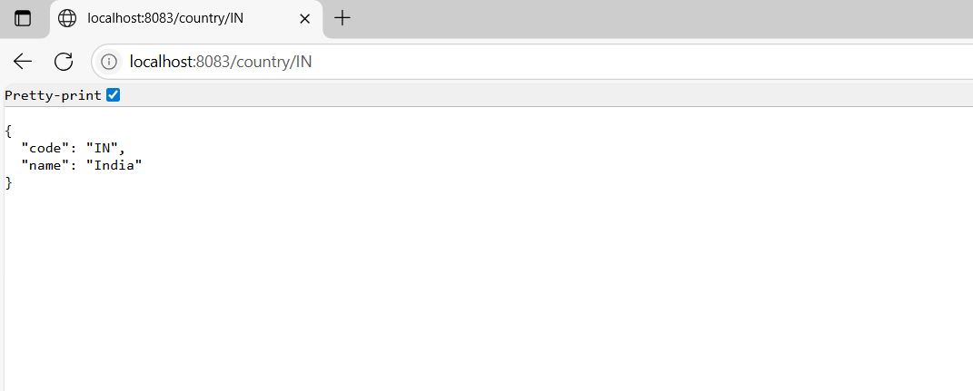

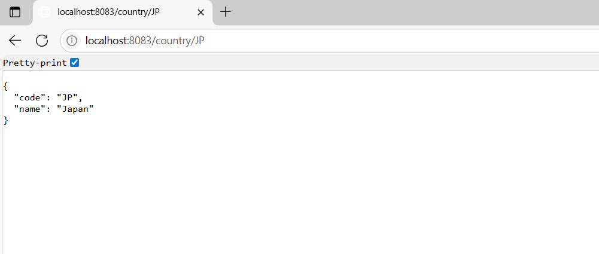

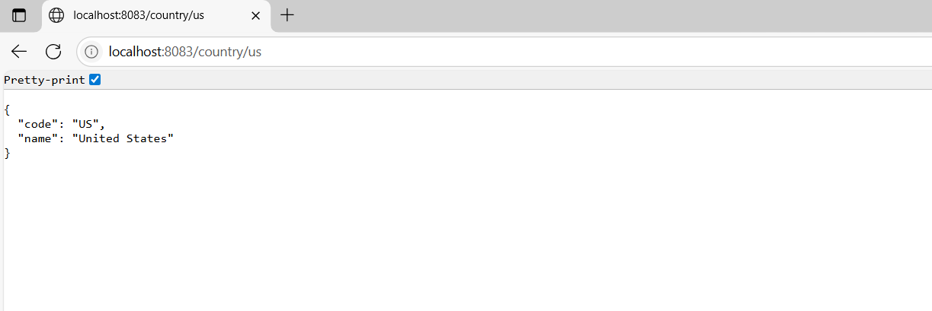

**📸 Screenshot: Console Logs**

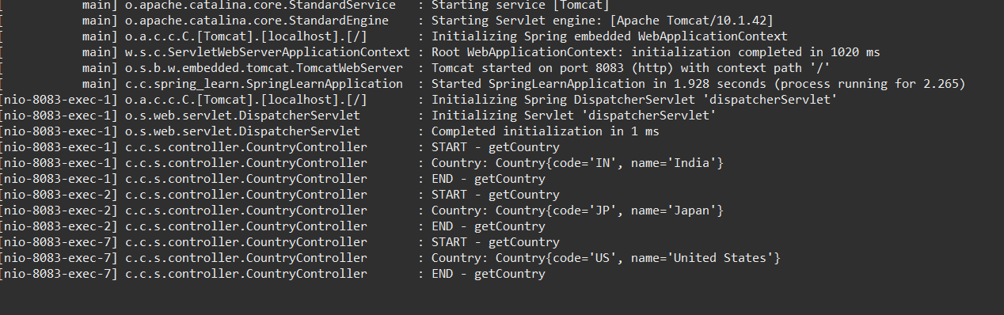

**Complete Screenshot :**

